Cricket Player Performance Tracking Application : CRICKSTATS

User Story:
As a Salesforce Admin, I want to create a comprehensive Player Performance Tracking Application within Salesforce to capture, manage, and analyze detailed match-by-match information of cricket players.The application will include custom objects such as Player and Match Performance, with carefully defined fields and relationships to ensure data accuracy, consistency, and accessibility.The Player object will store important player information such as player name, age, team, playing role, batting style, bowling style, and contact details.The Match Performance object will capture match-specific statistics such as matches played, runs scored, wickets taken, catches, strike rate, bowling economy, and overall performance.By leveraging Master-Detail and Lookup relationships, the application will maintain a strong connection between players and their individual match performances while ensuring data integrity.The system will allow administrators to easily create, update, view, and manage player and match-performance records from a centralized Salesforce environment.Reports and dashboards can be used to analyze player statistics, compare performances, identify consistent players, and monitor performance trends over time.The application will also help coaches and team managers access relevant performance information quickly and make data-driven decisions related to player development and team management.By using Salesforce automation, validation rules, reports, and dashboards, the system can reduce manual data entry, minimize errors, and improve the overall efficiency of performance tracking.The application will provide a structured and scalable platform that can be extended in the future with additional features such as team management, tournament tracking, player rankings, performance alerts, and advanced analytics.Overall, the proposed Salesforce application will provide an efficient solution for managing cricket player statistics, analyzing match performance, supporting player development, and improving strategic decision-making.

1. INTRODUCTION

1.1 Project Overview
CRICKSTATS is a Salesforce-based cricket player performance management application developed to record, manage, and analyze the performance of cricket players on a match-by-match basis. The application provides a centralized platform where player information and match performance details can be stored in a structured manner.
The system uses Salesforce custom objects, fields, relationships, validation rules, reports, dashboards, and automation features to efficiently manage cricket statistics. The Player object maintains basic player information, while the Match Performance object stores detailed statistics related to individual matches.
The application helps coaches, team managers, and sports analysts access player statistics quickly and analyze performance patterns. Instead of maintaining records manually in separate spreadsheets or documents, all information can be maintained within Salesforce.
The system can also support comparison of player performances, identification of performance trends, and generation of reports for better team planning. The use of dashboards provides a visual representation of important statistics, making the information easier to understand.
The proposed CRICKSTATS application provides a scalable foundation that can be extended with additional features such as team management, tournament management, player rankings, performance alerts, and advanced analytics.

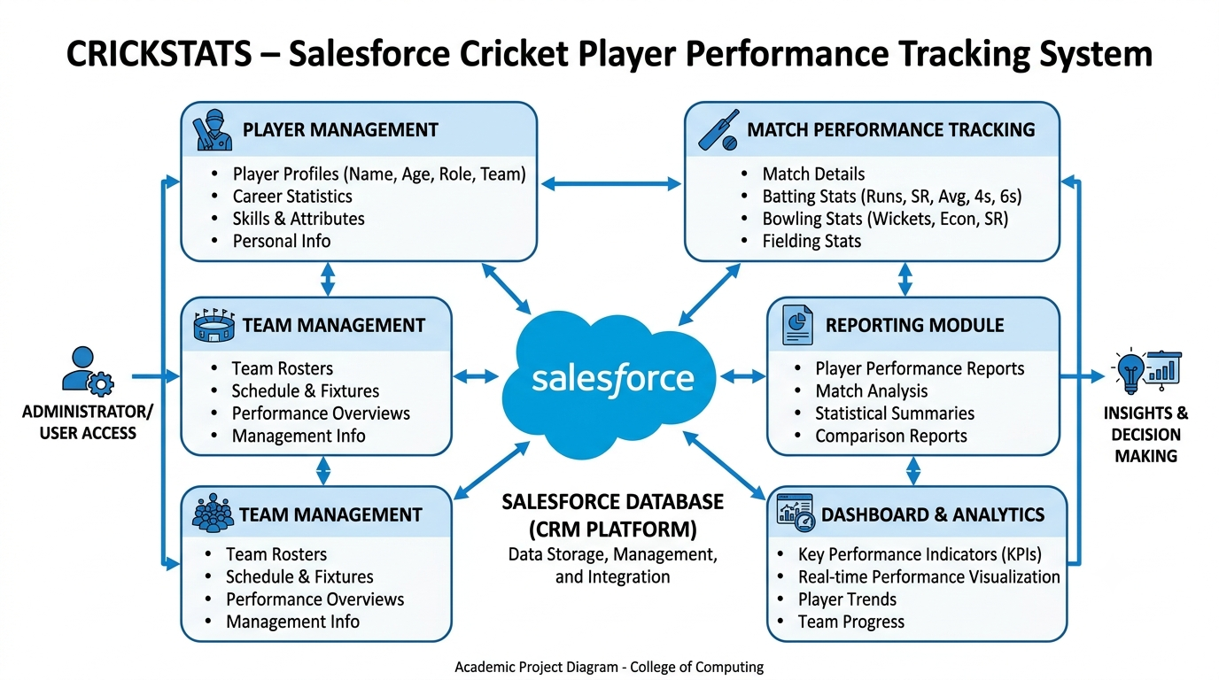

1.2 Purpose
The main purpose of the CRICKSTATS application is to create a centralized and efficient system for managing cricket player performance information.
The major purposes of the project are:
- To digitize player performance records.
- To maintain player information in a centralized Salesforce platform.
- To record match-by-match performance statistics.
- To improve the accuracy and consistency of cricket statistics.
- To reduce dependency on manual spreadsheets and paper records.
- To provide quick access to player performance information.
- To generate reports based on player and match statistics.
- To provide dashboards for visual analysis.
- To identify player performance trends.
- To support coaches and managers in team planning.
- To improve the efficiency of sports data management.
- To provide a scalable platform for future cricket analytics.
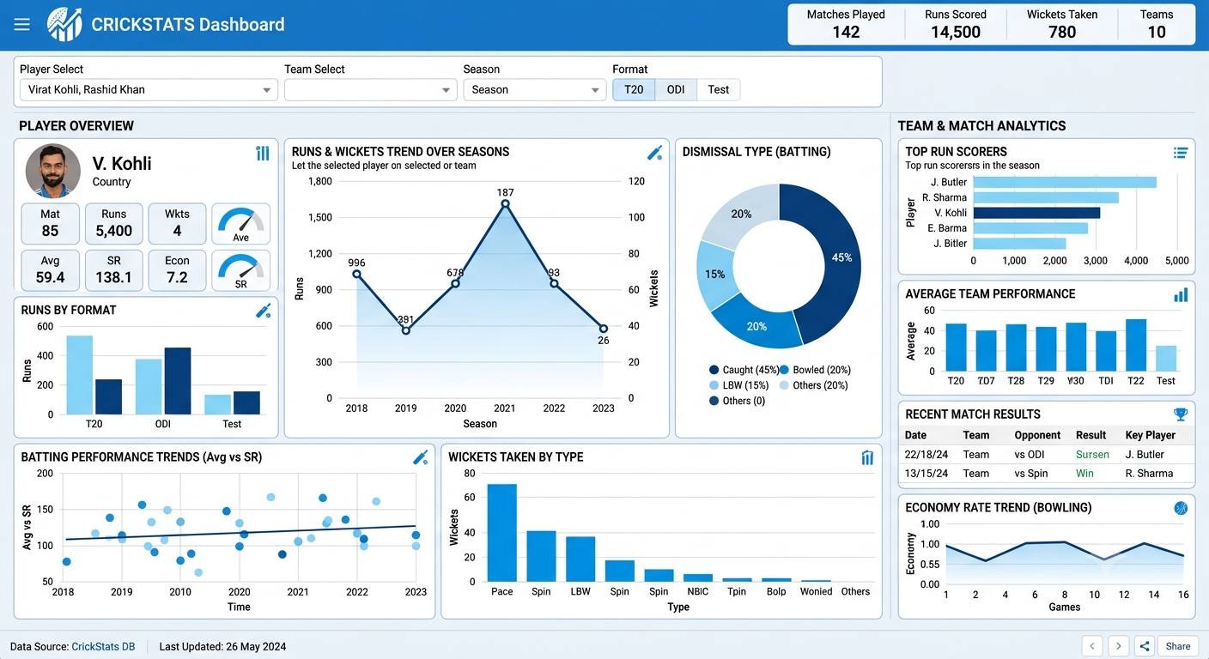

2. IDEATION PHASE

2.1 Problem Statement
The traditional method of maintaining cricket player statistics often involves spreadsheets, paper records, or multiple disconnected files. This can make it difficult for coaches, managers, and analysts to maintain accurate and up-to-date performance information.
CRICKSTATS addresses this problem by providing a centralized Salesforce application where player details and match performance records can be maintained systematically.

Problem Statement 1 – Coach
Category | Description
I am (Customer) | A cricket team coach
I'm trying to | Track player performance across multiple matches
But | I cannot easily access accurate and complete statistics
Because | Player data is maintained in different files and formats
Which makes me feel | Frustrated and uncertain during team planning

Problem Statement 2 – Team Manager
Category | Description
I am (Customer) | A cricket team manager
I'm trying to | Maintain complete and updated player records
But | Updating and verifying records takes considerable time
Because | Most performance records are maintained manually
Which makes me feel | Stressed and inefficient

Problem Statement 3 – Sports Analyst
Category | Description
I am (Customer) | A sports analyst
I'm trying to | Analyze player trends and generate performance reports
But | Comparing performances across matches is difficult
Because | There is no centralized analytics platform
Which makes me feel | Confused and dissatisfied

Additional Problem Statements

PS-4
Category | Description
I am (Customer) | A cricket administrator
I'm trying to | Maintain reliable player and match records
But | Duplicate and incomplete records may occur
Because | Data is entered and maintained manually
Which makes me feel | Concerned about data accuracy

PS-5
Category | Description
I am (Customer) | A team selection committee member
I'm trying to | Review player performance before team selection
But | Relevant statistics are not available in one place
Because | Performance information is distributed across different records
Which makes me feel | Uncertain when reviewing player statistics

PS-6
Category | Description
I am (Customer) | A performance analyst
I'm trying to | Identify changes in player performance over time
But | Historical comparisons are difficult
Because | Previous match data is not organized systematically
Which makes me feel | Limited in my analysis

2.2 Proposed Solution
CRICKSTATS proposes a centralized Salesforce-based solution for managing cricket player performance data. The system connects player information with individual match-performance records through Salesforce relationships.
The proposed application provides:
- Player Management – Store and manage player details.
- Match Performance Management – Record match-wise statistics.
- Relationship Management – Connect players with their performances.
- Data Validation – Improve data accuracy through validation rules.
- Reports – Generate performance-based reports.
- Dashboards – Display statistics visually.
- Automation – Reduce repetitive administrative tasks.
- Centralized Database – Maintain information in one Salesforce environment.
- Performance Analysis – Support comparison and trend analysis.

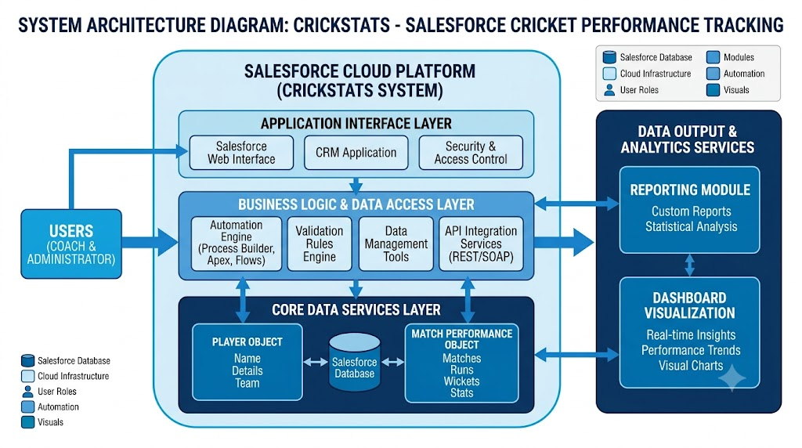

2.3 Ideation Process
The idea for CRICKSTATS was developed by identifying common challenges in maintaining cricket player performance records. Traditional methods may require multiple spreadsheets or documents, making it difficult to maintain consistency and quickly retrieve information.
The proposed idea was to use Salesforce because it provides tools for custom objects, relationships, automation, reports, dashboards, and data management within a single platform.
The ideation process includes:
- Identifying the problem.
- Understanding user requirements.
- Identifying important cricket performance data.
- Designing the required Salesforce objects.
- Establishing relationships between objects.
- Planning reports and dashboards.
- Identifying automation requirements.
- Designing a centralized performance tracking application.
- Considering future expansion of the system.
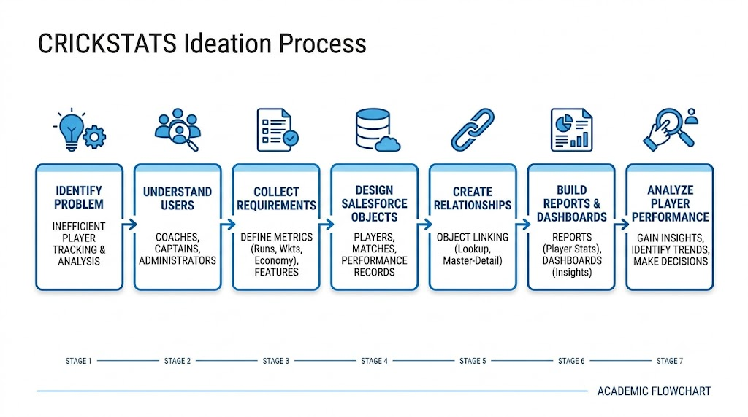

2.2 EMPATHY MAP CANVAS

Target Users
The CRICKSTATS application is designed to meet the requirements of different users involved in cricket performance management. The major target users are:
- Team Managers – Manage player information, match records, and team statistics.
- Coaches – Monitor player performance and review statistics for training and team planning.
- Sports Analysts – Analyze performance trends and generate statistical reports.
- Salesforce Administrators – Manage the application, configure objects, fields, relationships, permissions, and automation.
- Team Management Staff – Access relevant reports and performance information for administrative purposes.

Empathy Analysis
Aspect | Description
Think & Feel | Users need accurate, reliable, and easily accessible player performance information. They want better insights for planning and decision-making.
Hear | Users receive feedback from coaches, team managers, players, and management regarding player performance and team requirements.
See | Users may see information stored in multiple spreadsheets, documents, or separate data sources, making comparison difficult.
Say & Do | Users collect match statistics, update player records, prepare reports, and manually compare player performances.
Pain | Data entry errors, duplicate records, delayed updates, difficulty in finding information, and time-consuming manual reporting.
Gain | Faster access to information, centralized records, automated processes, improved reporting, and better performance analysis.

User Needs Identified
Based on the empathy analysis, the following major user needs were identified:
- A centralized platform for storing player information.
- Easy entry of match-by-match performance data.
- Accurate and consistent statistical records.
- Quick access to player performance history.
- Simple reports and dashboards.
- Secure access to player information.
- Reduced manual data entry and repetitive work.
- Easy comparison of player performance.
- Better visibility of performance trends.
- Support for data-driven team planning.
The empathy map helps the development team understand the actual requirements and difficulties faced by different users. These findings are used as inputs for designing the CRICKSTATS solution.
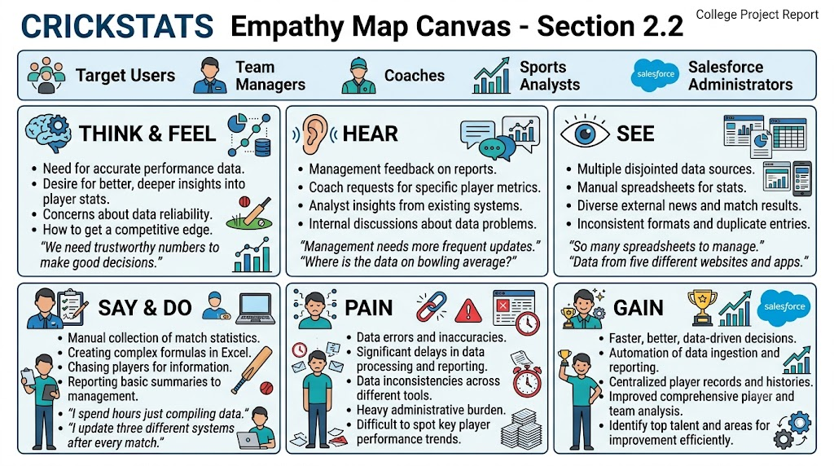

2.3 BRAINSTORMING

Brainstormed Ideas
During the brainstorming stage, several possible solutions were considered for managing cricket player performance information.

1. Web-Based Player Management System
A web-based application could be developed to maintain player details, match statistics, and reports. Users could access the application through a web browser.

2. Mobile Statistics Tracker
A mobile application could allow coaches and managers to enter match statistics directly from smartphones or tablets during or after a match.

3. Salesforce-Integrated CRM
Salesforce could be used to create a centralized application with custom objects, relationships, reports, dashboards, and automation features.

4. AI-Based Performance Prediction
An artificial intelligence-based system could analyze historical statistics and identify possible future performance trends.

5. Dashboard-Based Analytics
A dashboard-focused solution could display important statistics such as runs, wickets, batting average, strike rate, economy rate, and matches played using charts and graphical components.

6. Automated Reporting System
An automated reporting system could generate regular player and team performance reports based on stored match information.

Selected Idea
After considering the different ideas, the Salesforce-based performance tracking platform (CRICKSTATS) was selected as the proposed solution.
The selected idea combines centralized data management, automation, reporting, and dashboard-based analytics in a single platform. Salesforce custom objects can be used to store player and match performance information, while relationships can connect individual players with their corresponding match records.
The solution can also be extended in the future with advanced analytics, mobile access, AI-based predictions, tournament management, and automated notifications.

Reasons for Selecting CRICKSTATS
- Centralized storage of cricket statistics.
- Easy management of player records.
- Match-by-match performance tracking.
- Custom relationships between Salesforce objects.
- Easy report generation.
- Interactive dashboards.
- Automation using Salesforce tools.
- Secure access control.
- Scalable architecture for future enhancements.
- Reduced dependency on manual record management.

3. REQUIREMENT ANALYSIS PHASE

3.1 CUSTOMER JOURNEY MAP
The Customer Journey Map describes the different stages through which a user interacts with the CRICKSTATS application. It helps identify user activities, expectations, and possible difficulties at each stage.

Journey Stages
Login → Enter Player Data → Record Match Performance → Generate Reports → Analyze Results → Decision Making

Stage 1: Login
The user securely logs into the Salesforce application using authorized credentials. Access to features depends on the user's assigned permissions.

Stage 2: Enter Player Data
The administrator or authorized user creates and maintains player records. Information such as player name, age, team, playing role, batting style, and bowling style can be recorded.

Stage 3: Record Match Performance
After a match, authorized users enter relevant performance information. This may include runs scored, wickets taken, catches, overs bowled, strike rate, and economy rate.

Stage 4: Generate Reports
The system uses stored information to generate reports. Reports can be filtered according to players, matches, teams, or performance-related fields.

Stage 5: Analyze Results
Coaches, managers, and analysts review reports and dashboards to understand player performance and identify trends.

Stage 6: Decision Making
The analyzed information can support activities such as training planning, performance monitoring, team management, and player development.

Customer Journey Summary
Stage | User Activity | System Support
Login | Access application | Authentication and permissions
Player Data | Enter/update player details | Player object
Match Data | Record statistics | Match Performance object
Reports | Generate reports | Salesforce Reports
Analysis | Review statistics | Dashboards and charts
Decision Making | Use insights for planning | Centralized performance information

3.2 SOLUTION REQUIREMENTS
The solution requirements define the capabilities and quality characteristics required for the successful implementation of the CRICKSTATS application.

Functional Requirements
FR No. | Requirement | Description
FR-1 | Player Registration | The system should allow authorized users to create and maintain player records.
FR-2 | Match Performance Entry | Users should be able to record match-wise player performance.
FR-3 | Player Record Management | Users should be able to view and update player information based on permissions.
FR-4 | Relationship Management | Player records should be connected with their corresponding match performance records.
FR-5 | Dashboard Generation | The system should display important performance statistics using dashboards.
FR-6 | Report Creation | Users should be able to generate reports based on stored performance data.
FR-7 | Data Validation | The system should validate important fields and reduce incorrect data entry.
FR-8 | Flow Automation | Salesforce Flow can be used to automate selected business processes.
FR-9 | Search and Filtering | Users should be able to find relevant player and performance information efficiently.
FR-10 | User Access Management | Access to application features should be controlled according to user permissions.

NON-FUNCTIONAL REQUIREMENTS (NFRs) – CRICKSTATS

NFR-1: Usability
The system should be simple and easy to understand for coaches, managers, analysts, and administrators. Users should be able to perform common tasks without requiring extensive technical knowledge.

Requirements
- Simple and intuitive user interface.
- Clear navigation.
- Well-organized forms.
- Easy-to-read reports and dashboards.
- Consistent page layout.
- Minimal learning curve.
- Clear error messages.

Example
A new coach should be able to:
- Log in to the system.
- Search for a player.
- View match performance.
- Generate or open a performance report.
- Understand the displayed statistics without requiring specialized technical training.
The Salesforce Lightning interface provides a structured environment for managing records, reports, and dashboards.

NFR-2: SECURITY
The system must protect player and performance information from unauthorized access or modification.

Requirements
- Role-based access control.
- Secure authentication.
- Profiles and permission sets.
- Appropriate object and field-level permissions.
- Record-level access control.
- Secure handling of user information.
- Regular data protection and recovery procedures.

Examples
- Coaches can be given access to relevant player performance information.
- Managers can be provided with appropriate record-editing permissions.
- Analysts can be provided with report and dashboard access.
- Administrators can manage configuration and application settings.
Salesforce security features such as Profiles, Permission Sets, Roles, Sharing Settings, and Field-Level Security can be used according to the application's requirements.

NFR-3: RELIABILITY
The system should operate consistently and maintain accurate player and match performance information.

Requirements
- Accurate data storage.
- Data validation.
- Error handling.
- Consistent record relationships.
- Reliable report generation.
- Data recovery and backup procedures.
- Prevention of accidental data duplication where applicable.

Example
If an authorized user enters match statistics incorrectly, validation rules and controlled field values can help prevent invalid information from being saved.
The Salesforce platform provides cloud-based data management capabilities, while appropriate configuration and administrative procedures can support data reliability.

NFR-4: PERFORMANCE
The system should provide responsive access to player records, reports, and dashboards while handling the expected volume of cricket performance information.

Requirements
- Responsive record pages.
- Efficient report generation.
- Smooth dashboard loading.
- Efficient data retrieval.
- Appropriate filtering of large datasets.
- Reduced unnecessary processing.
- Scalable data design.

Example
When an analyst generates a performance report covering many player and match records, the system should retrieve and display the required information efficiently.
Performance depends on factors such as Salesforce configuration, report design, data volume, network conditions, and platform limits. Therefore, reports and dashboards should be designed carefully to avoid unnecessary processing.

NFR-5: SCALABILITY
The application should be capable of supporting future growth in the number of players, matches, teams, and performance records.

Requirements
- Support additional player records.
- Support increasing match-performance records.
- Allow additional fields and objects.
- Support new reports and dashboards.
- Allow future integration with other systems.
- Support additional automation features.

Example
The application can initially be used by a single cricket team and later extended to support multiple teams or tournaments by adding suitable objects and relationships.

NFR-6: MAINTAINABILITY
The application should be easy for a Salesforce Administrator to maintain and update.

Requirements
- Clearly named objects and fields.
- Proper documentation.
- Organized automation.
- Controlled permissions.
- Easy-to-maintain reports and dashboards.
- Proper relationship design.
- Regular review of configuration.
A well-structured Salesforce application makes it easier to add new features, correct configuration issues, and adapt the system to changing requirements.

NFR-7: DATA INTEGRITY
The system should maintain accurate, complete, and consistent information across Player and Match Performance records.

Requirements
- Required fields for important information.
- Validation rules.
- Appropriate field data types.
- Correct object relationships.
- Prevention of invalid values.
- Controlled record creation and modification.
For example, a Match Performance record should be associated with the appropriate player so that performance statistics can be accurately attributed to the correct individual.

3.3 Data Flow Diagram
The Data Flow Diagram (DFD) represents how information moves through the CRICKSTATS application. It explains the flow of player and match-performance information from the user interface to the Salesforce objects and finally to reports and dashboards.
The main data flow of the system is:
User → Salesforce UI → Player Object → Match Performance Object → Reports → Dashboard
The user interacts with the Salesforce Lightning interface to enter and manage player information. The entered information is stored in the Player object. Match-related performance details are then recorded in the Match Performance object and associated with the appropriate player.
The stored information can be retrieved and processed through Salesforce Reports. These reports provide organized information about player and match performance. The results can then be presented through interactive dashboards for easier analysis.
The data flow helps ensure that information is maintained in a structured manner and can be accessed by authorized users when required.

Main Components of Data Flow
1.User:
The user may be a coach, team manager, sports analyst, or Salesforce administrator. Users interact with the system according to their assigned permissions.
2.Salesforce Lightning UI:
The Lightning interface provides the user interface through which records can be created, viewed, updated, and managed.
3.Player Object:
The Player object stores important information about cricket players and acts as the main source of player-related information.
4. Match Performance Object:
The Match Performance object stores match-by-match statistics such as runs, wickets, catches, overs, strike rate, and economy rate.
5. Reports:
Salesforce Reports organize stored information into useful formats for filtering, grouping, and analysis.
6. Dashboard:
Dashboards provide visual representations of important statistics through charts, tables, and performance indicators.
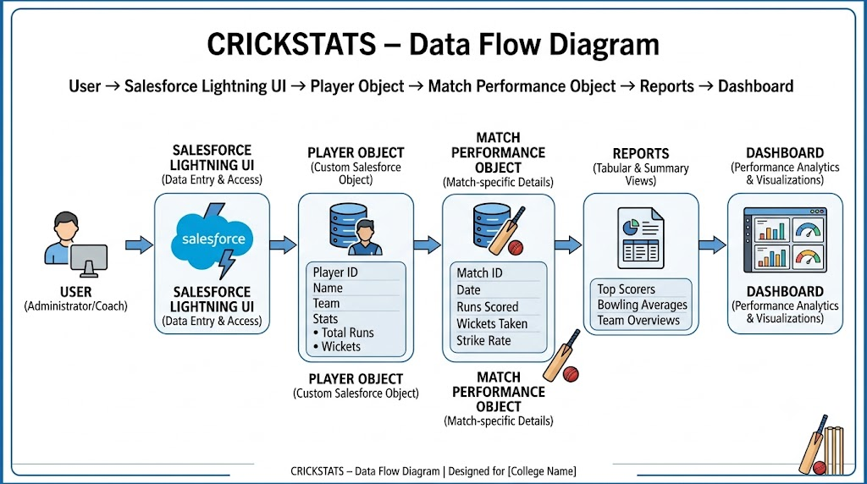

3.4 TECHNOLOGY STACK
The CRICKSTATS application uses Salesforce technologies to provide a centralized environment for storing, processing, automating, and analyzing cricket player performance information.
The technology stack consists of different layers that work together to provide the required functionality.
Layer | Technology
Frontend | Salesforce Lightning
Analytics | Salesforce Reports & Dashboards
Automation | Salesforce Flows
Backend | Salesforce Objects
Database | Salesforce Cloud

Frontend – Salesforce Lightning
Salesforce Lightning provides the user interface of the CRICKSTATS application. Users can access Player and Match Performance records through Lightning pages, tabs, forms, and navigation components.

Analytics – Reports and Dashboards
Salesforce Reports and Dashboards are used to organize and visualize player performance information. Reports can display detailed records, while dashboards provide graphical representations of important statistics.

Automation – Salesforce Flows
Salesforce Flow can be used to automate repetitive business processes. For example, flows can perform actions when a player or match-performance record is created or updated.

Backend – Salesforce Objects
Salesforce Objects are used to store application data. The main custom objects in CRICKSTATS are the Player object and Match Performance object.

Database – Salesforce Cloud
The Salesforce cloud platform provides the environment for storing and managing application records. It enables authorized users to access the system through the Salesforce platform.

Advantages of the Technology Stack
The selected technology stack provides:
- Centralized data management.
- Easy record management.
- Automation of repetitive tasks.
- Interactive reporting.
- Dashboard-based visualization.
- Secure access control.
- Scalability for future development.
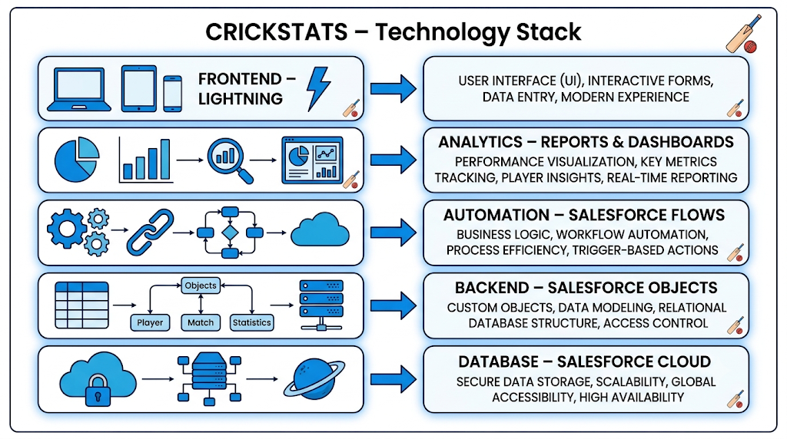
- Easy administration through Salesforce tools.
4. PROJECT DESIGN PHASE

4.1 PROBLEM–SOLUTION FIT
The CRICKSTATS system is designed to address the major problems associated with traditional cricket performance management.
Earlier, player and match information could be maintained using spreadsheets, paper records, or multiple files. Such methods may require significant manual effort and can make it difficult to maintain consistent and easily accessible information.
CRICKSTATS addresses these challenges by providing a centralized Salesforce-based platform. Player information and match performance records can be stored systematically using custom Salesforce objects.

Problem 1: Manual Data Management
Traditional manual methods require users to enter and update information repeatedly. This can increase the possibility of data-entry errors.
CRICKSTATS Solution:
The Salesforce application provides structured forms and fields for entering player and match information.

Problem 2: Scattered Data
When information is stored in different files, users may find it difficult to access complete player performance history.
CRICKSTATS Solution:
The application maintains player and match-performance information in a centralized Salesforce environment.

Problem 3: Difficult Performance Analysis
Manually comparing player performance across several matches can be time-consuming.
CRICKSTATS Solution:
Reports and dashboards can organize statistics and present them in an easier-to-analyze format.

Problem 4: Delayed Reporting
Creating reports manually may require additional time, especially when the number of records increases.
CRICKSTATS Solution:
Salesforce Reports and Dashboards can provide organized performance information from stored records.

Problem 5: Data Access and Security
Different users may require different levels of access to player information.
CRICKSTATS Solution:
Salesforce security and permission features can be configured to provide appropriate access to users.

Problem–Solution Summary
Existing Problem | CRICKSTATS Solution | Expected Benefit
Manual records | Salesforce records | Reduced manual effort
Scattered information | Centralized objects | Easier access
Data-entry errors | Validation rules | Better data quality
Difficult analysis | Reports and dashboards | Better visibility
Delayed reporting | Automated reporting | Faster information access
Access issues | Salesforce permissions | Controlled access
Thus, CRICKSTATS provides a structured approach to managing cricket player performance information and supports users in accessing and analyzing relevant statistics.

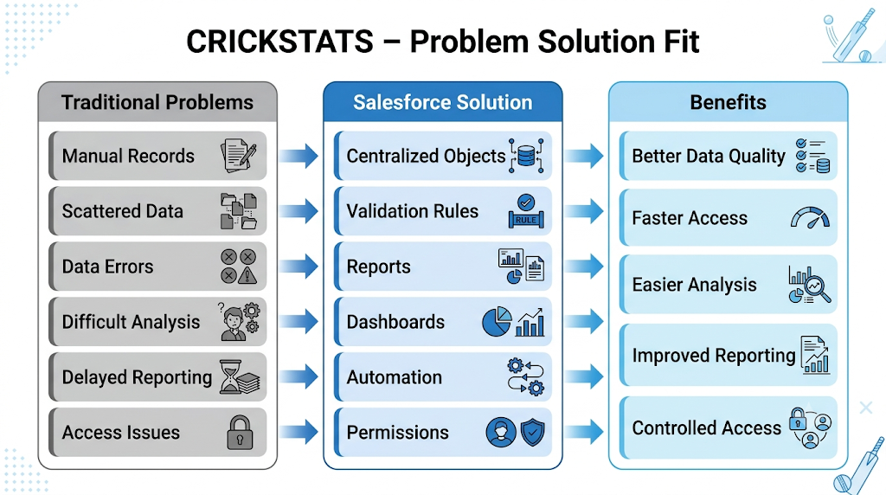
4.2 PROPOSED SOLUTION

Description
CRICKSTATS provides a Salesforce-based platform for managing cricket player and match-performance information. The proposed solution uses Salesforce custom objects, relationships, automation, reports, and dashboards to create a structured performance management system.
The major components of the proposed solution are:

1. Custom Objects
The system uses custom objects such as:
- Player
- Match Performance
The Player object stores player-related information, while the Match Performance object stores match-wise statistics.

2. Master-Detail Relationship
A Master-Detail relationship can be used to establish a strong relationship between Player and Match Performance records. This allows individual match-performance records to be associated with the relevant player.

3. Roll-Up Summary
Roll-up summary fields can be used with a suitable Master-Detail relationship to calculate summary information from related records. Examples include total runs, total wickets, or the number of related performance records, depending on the application's configuration.

4. Lightning App
The CRICKSTATS Lightning App provides a centralized interface through which authorized users can access relevant objects, records, reports, and dashboards.

5. Automated Flows
Salesforce Flows can be configured to automate selected processes and reduce repetitive administrative tasks.

6. Interactive Dashboards
Dashboards provide visual information about player performance and help users understand statistics through charts and other components.

Key Features

1. Centralized Database
Player and match-performance information is maintained in a centralized Salesforce environment.

2. Performance Statistics
The system stores match-wise performance information and allows users to review player statistics.

3. Secure Access
Salesforce security and permission features can be used to control access to records and application functionality.

4. Scalable Design
The system can be extended by adding additional objects, fields, reports, dashboards, and automation.

5. Easy Reporting
Salesforce Reports allow users to organize and filter performance information according to their requirements.

6. Dashboard Visualization
Important statistics can be represented using charts and dashboard components for easier interpretation.
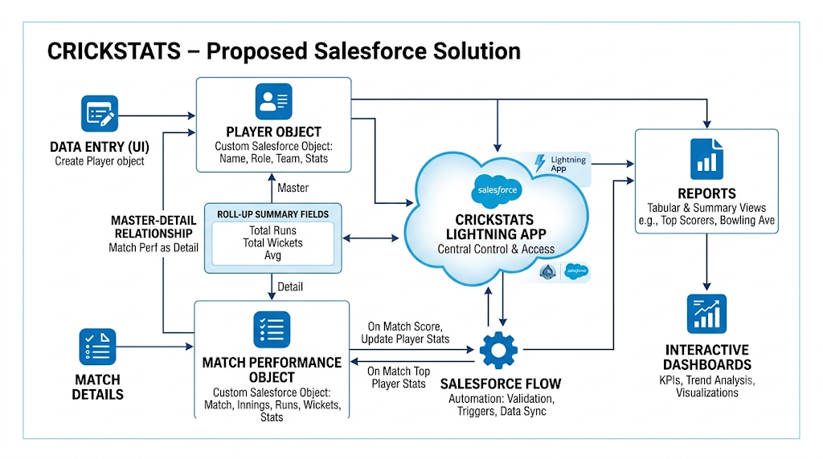

4.3 SOLUTION ARCHITECTURE
The CRICKSTATS solution architecture describes how different Salesforce components work together to provide the complete application.

Architecture Layers

1. Presentation Layer – Lightning UI
The Presentation Layer is the user-facing part of the application. Salesforce Lightning provides pages, tabs, forms, navigation, and record views through which users interact with CRICKSTATS.

2. Application Layer – Flows and Logic
The Application Layer contains business processes and automation. Salesforce Flows can be used to perform automated actions based on defined conditions and record changes.

3. Data Layer – Salesforce Objects
The Data Layer stores the application's main information. Player and Match Performance objects form the core data structure of CRICKSTATS.

4. Analytics Layer – Reports and Dashboards
The Analytics Layer converts stored data into useful information through reports, charts, and dashboards.

Overall Architecture Flow
User → Lightning UI → Salesforce Logic/Flows → Salesforce Objects → Reports → Dashboards → Performance Insights
This layered architecture provides a clear separation between user interaction, application processing, data storage, and analytics.

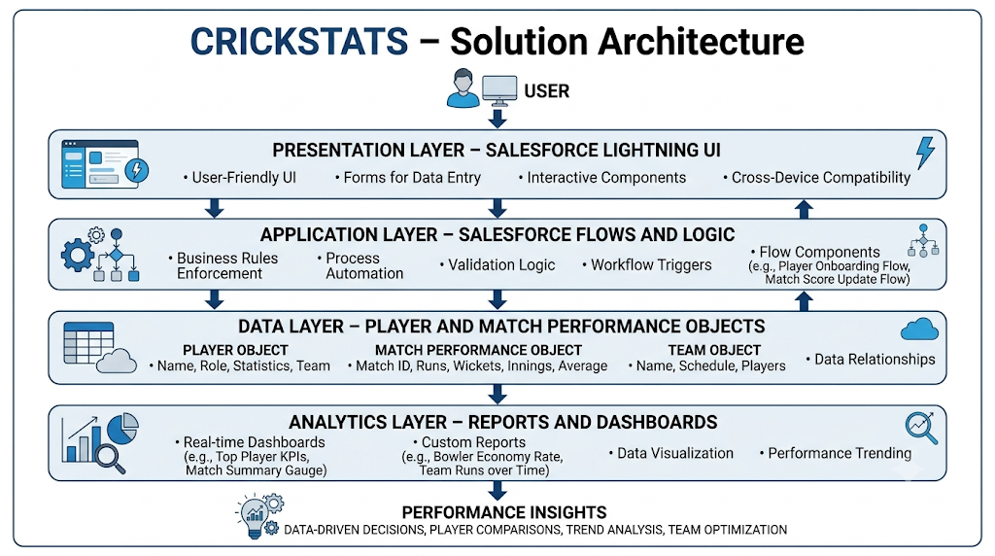

5. PROJECT PLANNING & SCHEDULING

5.1 PROJECT PLANNING
The CRICKSTATS project follows an Agile-based development approach. The project is divided into smaller development activities so that each part of the application can be designed, implemented, and reviewed systematically.
The main development sequence is:
Developer Setup → Object Creation → Data Structure → Navigation → Lightning App → Automation → Reports → Dashboards → Testing
Agile planning allows the development team to organize work into manageable sprints. Each sprint contains specific user stories and tasks with assigned story points and priorities.

Development Approach
The project planning process includes:
- Requirement identification.
- Product backlog preparation.
- Sprint planning.
- Object and field creation.
- Relationship configuration.
- UI and navigation setup.
- Automation development.
- Report and dashboard creation.
- Testing and review.
- Final implementation.

Sprint-Wise Development
The project can be divided into multiple sprints. Each sprint focuses on a specific set of functionalities.
Sprint 1: Developer setup and initial data modeling.
Sprint 2: Navigation, Lightning App, data structure, page layouts, and validation.
Sprint 3: Automation and Salesforce Flow development.
Sprint 4: Reports, dashboards, testing, documentation, and final review.
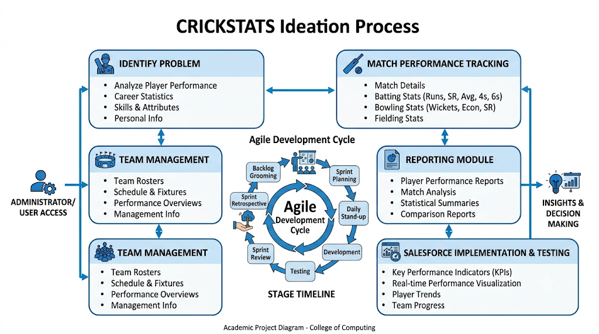

PRODUCT BACKLOG, SPRINT SCHEDULE, AND ESTIMATION
The Product Backlog contains the features and tasks required to develop the CRICKSTATS application. Each user story describes a specific requirement from the perspective of an application user or administrator.
Sprint | Functional Requirement / Epic | User Story Number | User Story / Task | Story Points | Priority | Team Member
Sprint-1 | Developer Setup | USN-1 | As an admin, I want to create a Salesforce developer account so that I can configure and deploy the CRICKSTATS system. | 1 | High | Member 1
Sprint-1 | Data Modeling | USN-2 | As an admin, I want to create Player and Match Performance objects so that player and match data can be stored systematically. | 3 | High | Member 2
Sprint-2 | Navigation | USN-3 | As a user, I want separate tabs for each object so that I can easily navigate and manage records within the application. | 3 | High | Member 3
Sprint-2 | UI Design | USN-4 | As a coach, I want a dedicated Lightning App so that all performance tracking features are accessible from one application. | 3 | High | Member 4
Sprint-2 | Data Structure | USN-5 | As an admin, I want to create player and match fields so that complete performance details can be captured accurately. | 5 | Medium | Member 1
Sprint-2 | Data Structure | USN-6 | As a user, I want customized page layouts so that only relevant fields are displayed during data entry. | 5 | High | Member 2
Sprint-2 | Automation | USN-7 | As a system, I want to validate player and match inputs so that incorrect data entries are prevented. | 3 | High | Member 4
Sprint-3 | Automation | USN-8 | As a system, I want automated flows to update player statistics so that performance data remains accurate. | 5 | High | Member 1

The backlog can be updated throughout development as new requirements are identified or existing requirements change.

PROJECT TRACKER, VELOCITY & BURNDOWN CHART
The project tracker is used to monitor sprint progress and compare planned work with completed work. Story points provide a simple way to estimate the relative effort required for each user story.
Sprint | Total Story Points | Duration | Sprint Start Date | Sprint End Date (Planned) | Story Points Completed | Sprint Release Date (Actual)
Sprint-1 | 20 | 6 Days | 24 Oct 2022 | 29 Oct 2022 | 20 | 29 Oct 2022
Sprint-2 | 20 | 6 Days | 31 Oct 2022 | 05 Nov 2022 | — | —
Sprint-3 | 20 | 6 Days | 07 Nov 2022 | 12 Nov 2022 | — | —
Sprint-4 | 20 | 6 Days | 14 Nov 2022 | 19 Nov 2022 | — | —

Sprint Progress
Sprint progress can be measured using the number of completed story points. Sprint 1 contains a total of 20 story points, with 20 story points shown as completed.
The remaining sprint values should be updated according to the actual progress of the project.

Velocity
Velocity represents the amount of work completed by the team during a sprint. It can be calculated using the total story points completed in each sprint.
Tracking velocity helps the development team understand its working capacity and improve future sprint planning.

Burndown Chart
A burndown chart represents the amount of remaining work during a sprint. As tasks are completed, the number of remaining story points should decrease.
The chart can be updated at regular intervals to monitor whether the team is progressing according to the sprint plan.

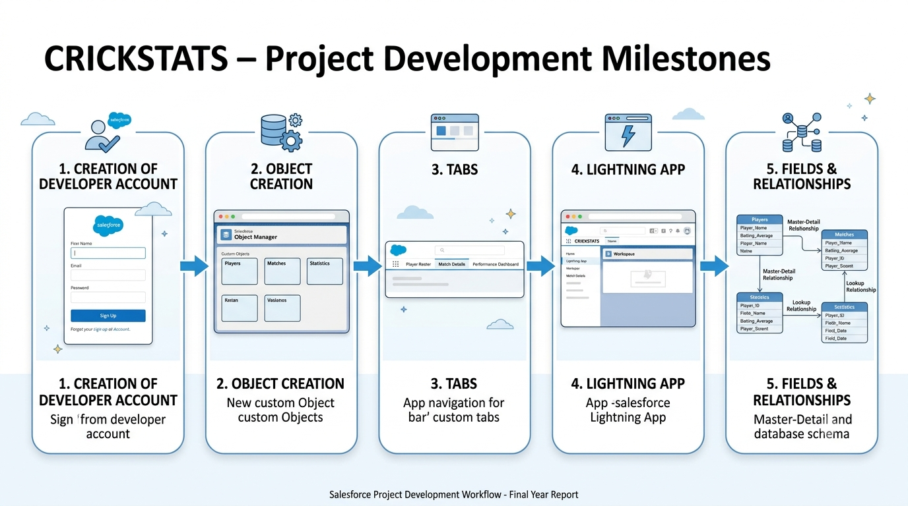
6. PROJECT DEVELOPMENT PHASE
The Project Development Phase describes the practical implementation of the CRICKSTATS application in Salesforce. The development process is divided into milestones so that each major component can be implemented and verified systematically.

Project Flow
Milestone 1 → Milestone 2 → Milestone 3 → Milestone 4 → Milestone 5

Milestone 1: Creation of Developer Account
The first milestone is the creation and configuration of the Salesforce development environment. The administrator creates or accesses the required Salesforce environment and prepares it for application development.
The development environment provides the platform required to create custom objects, fields, relationships, applications, automation, reports, and dashboards.

Milestone 2: Object Creation
The second milestone focuses on creating the main custom objects required for CRICKSTATS.
The primary objects are:
- Player
- Match Performance
The Player object stores player-related details, while Match Performance stores match-specific statistics.
The objects form the foundation of the application's data model.

Milestone 3: Tabs
After creating the objects, appropriate tabs are configured so that users can easily access the Player and Match Performance records.
Tabs improve navigation and allow users to move between different areas of the application efficiently.

Milestone 4: The Lightning App
The CRICKSTATS Lightning App is configured to bring the required objects and features together in one application.
The application can include:
- Player tab.
- Match Performance tab.
- Reports.
- Dashboards.
- Navigation items.
- Other relevant Salesforce components.
This provides users with a centralized interface for accessing the application's functionality.

Milestone 5: Fields & Relationships
The final milestone in this initial development stage involves creating fields and relationships between the objects.
Important fields can be created for storing player details and match-performance statistics.
A relationship between Player and Match Performance allows performance records to be associated with the relevant player.
The relationship structure improves data organization and makes it possible to generate meaningful reports based on player and match information.

Milestone 6: Roll-Up Summary
The Roll-Up Summary field was created in the CRICKSTATS Salesforce application to automatically calculate and display summary information from related Match Performance records. This feature helps the team management and coaching staff obtain important player performance statistics without manually calculating the values.
The Roll-Up Summary is configured on the Player object using the relationship between the Player and Match Performance objects. Since multiple match performance records can be associated with a player, the Roll-Up Summary can calculate values such as the total number of matches played, total runs scored, total wickets taken, or other relevant performance values based on the project design.

Purpose of Roll-Up Summary
The main purpose of the Roll-Up Summary is to provide automatically calculated performance information at the player level. Whenever a related Match Performance record is added or updated, Salesforce can automatically update the corresponding summary value.

Benefits
- Automatically calculates player performance totals.
- Reduces manual calculation.
- Improves data accuracy.
- Provides quick access to player statistics.
- Helps coaches and analysts evaluate performance.
- Supports dashboard and report generation.
- Saves time when managing multiple match records.

Milestone 7: Flows
Salesforce Flows were implemented in the CRICKSTATS application to automate repetitive processes and reduce manual work. Flow Builder provides a visual way to create automation by defining a sequence of actions that Salesforce performs when specific conditions are met.
In CRICKSTATS, Flows can be used to automate processes related to Player and Match Performance records. For example, when a Match Performance record is created or updated, a Flow can perform predefined actions based on the configured conditions.

Purpose of Flows
The main purpose of using Salesforce Flows is to automate business processes and improve the efficiency of the application. Instead of requiring users to perform every operation manually, the system can automatically execute predefined actions.

Flow Components
The CRICKSTATS Flow can contain the following major components:
- Start – Defines when the Flow begins execution.
- Get Records – Retrieves required Player or Match Performance records.
- Decision – Checks conditions and determines which path the Flow should follow.
- Assignment – Assigns values to variables or fields.
- Update Records – Updates existing Salesforce records.
- Create Records – Creates new records when required.
- End – Completes the Flow process.

Flow Process
The general Flow process in CRICKSTATS can be represented as:
Record Created/Updated → Flow Starts → Get Records → Check Conditions → Perform Action → Update/Create Records → Flow Ends

Benefits of Flows
- Automates repetitive tasks.
- Reduces manual data entry.
- Improves consistency.
- Reduces human errors.
- Saves time for users.
- Supports efficient player performance management.
- Makes the application more scalable.
- Helps maintain accurate and updated information.

Project Development Summary
The development process follows a structured sequence:
Developer Environment → Objects → Tabs → Lightning App → Fields & Relationships
Each milestone contributes to building the foundation of the CRICKSTATS application. After these activities, additional stages such as automation, reports, dashboards, testing, and final deployment can be completed.

Implementation

Milestone 1 - Salesforce Developer Account Creation

Activity 1: Creating Developer Account
Creating a developer org in Salesforce.
- Go to the Salesforce Developer signup page.
- On the sign-up form, enter the following details:
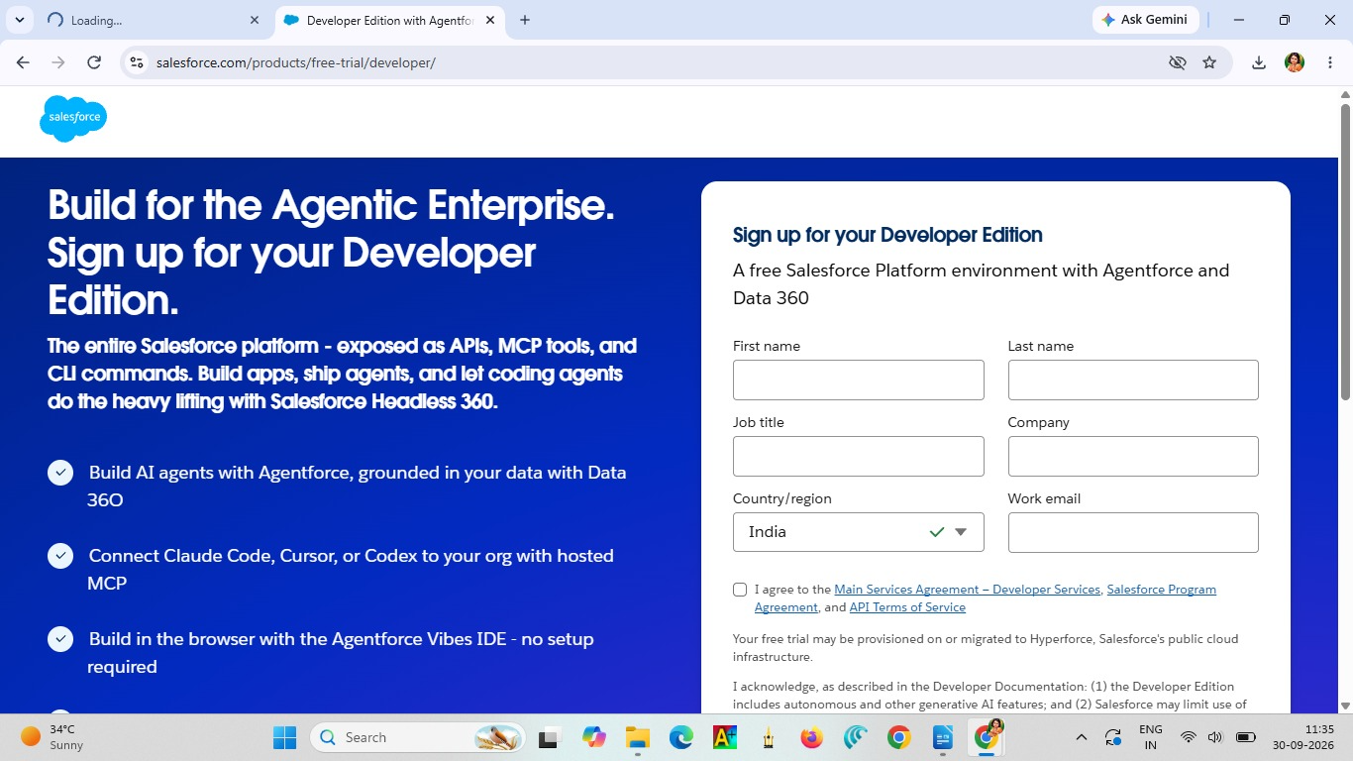
- First name & Last name
- Email
- Role: Developer
- Company: College or Company Name
- Country: India
- Postal Code: Pin code
- Username: Should be a combination of your name and company.
This need not be an actual email ID. You can give anything in that format:
username@organization.com
Click on Sign Me Up after filling these details.

Activity 2: Account Activation
- Go to the inbox of the email that you used while signing up. Click on the Verify Account option to activate your account. The email may take 5–10 minutes.
- Click on Verify Account.
- Give a password and answer a security question and click on Change Password.
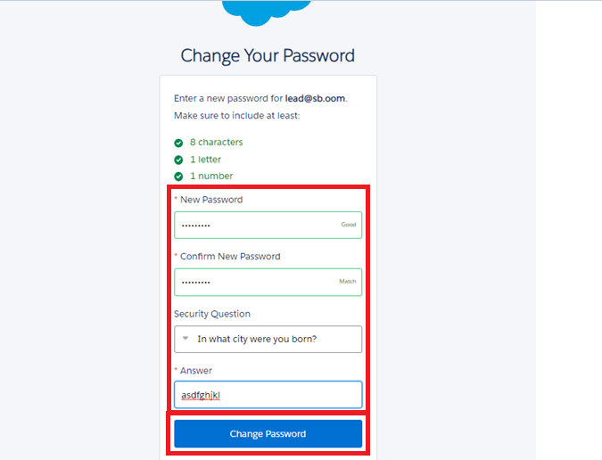
- Then you will be redirected to your Salesforce Setup page.

Milestone 2 - Object Creation

Activity 1: Player Object
1.In your Salesforce org, click the Gear icon on the top left and select Setup to open Setup.
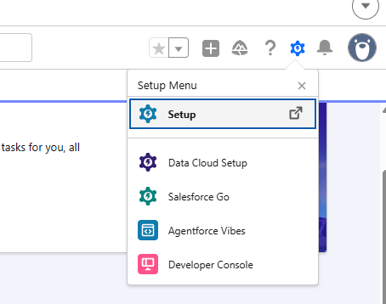

2.Click the Object Manager tab. If you don’t see it, enter Object Manager in the Quick Find box.
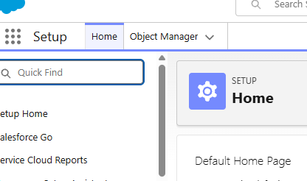

3.On the Object Manager page, click Create | Custom Object.
- From the setup page → Click on Object Manager → Click on Create → Click on Custom Object.
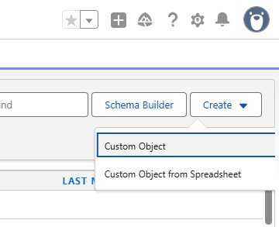

- Label: Player
- Plural Label: Players
- Enter Record Name Label and Format:
  - Record Name: Player Name
  - Data Type: Text

- In Optional Features, check the boxes for:
  - Allow Reports
  - Allow Activities
  - Track Field History
- Search Status: Check the box for Allow Search.
- Click Save.

Activity 2: Match Performance Object
- From the Setup page → Click on Object Manager → Create → Custom Object.
- Enter the following details:
- Label: Match Performance
- Plural Label: Match Performances
- Enter Record Name Label and Format:
  - Record Name: Customer Account Name
  - Data Type: Text
- In Optional Features, check the boxes for:
  - Allow Reports
  - Allow Activities
  - Track Field History
- Search Status: Check the box for Allow Search.
- Click Save.

Milestone 3 - Tabs

Activity 1: Custom Tabs Creation
- Go to the Setup page → type Tabs in the Quick Find bar → click on Tabs → click New under Custom Object Tabs.
- Select Object (Player) → Select the Tab Style → click Next.
  - On the Add to Profiles page, keep it as default → click Next.
  - On the Add to Custom App page, uncheck Include Tab.
- Make sure that Append tab to users' existing personal customizations is checked.
- Click Save.
- Repeat the same steps for Match Performances.
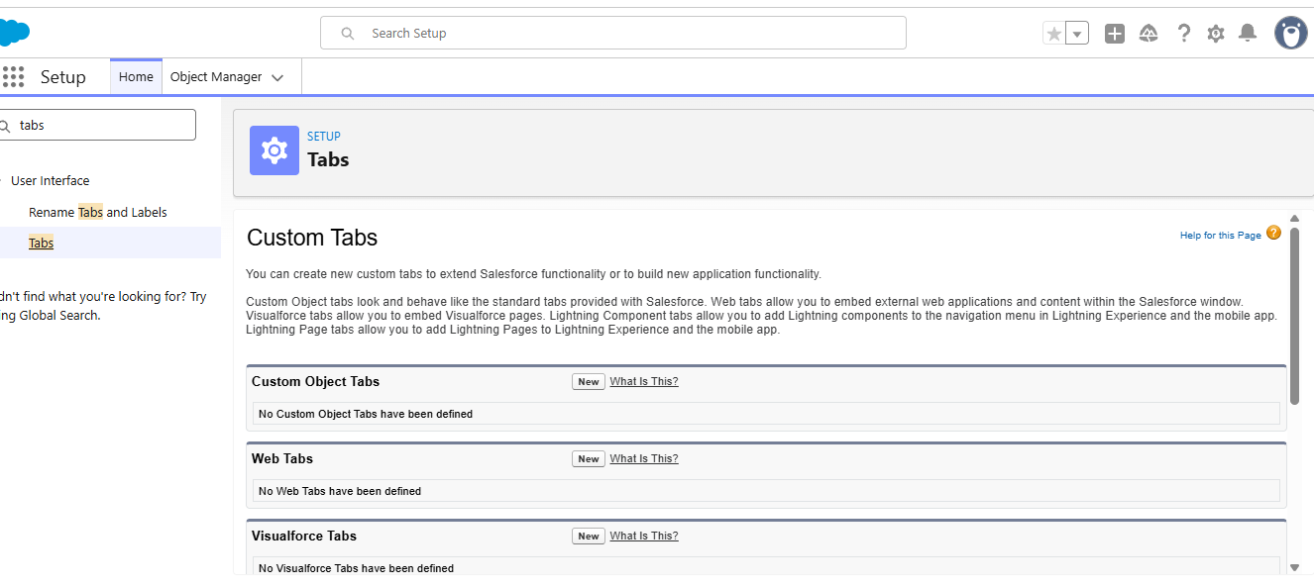

Milestone 4 - The Lightning App

Activity 1: Create a Lightning App
- Go to the Setup page → search “App Manager” in Quick Find → select “App Manager” → click on New Lightning App.
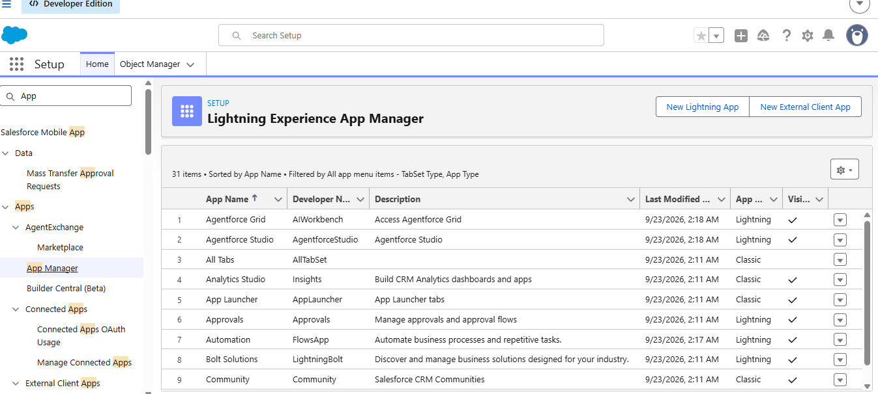
- Fill the app name in App Details and Branding as follows:
- App Name: CRICKSTATS
- Developer Name: Auto Populates
- Add Image: Optional (if you want to give any image, you can; otherwise, it is not mandatory)
- Primary Color: Enter the Hex value or leave it as default.
Then click Next.
- In App Options:
- Navigation Style: Standard Navigation
- Setup Experience: Setup
- Supported Form Factors: Desktop and Phone
Then click Next.
- In Utility Items:
- Utility Bar Alignment: Default
Then click Next.
- In Navigation Items, select the created Custom Objects and required Standard Objects:
- Players
- Match Performances
- Reports
- Dashboards
- To add User Profiles, select:
- System Administrator
- Click Save & Finish.

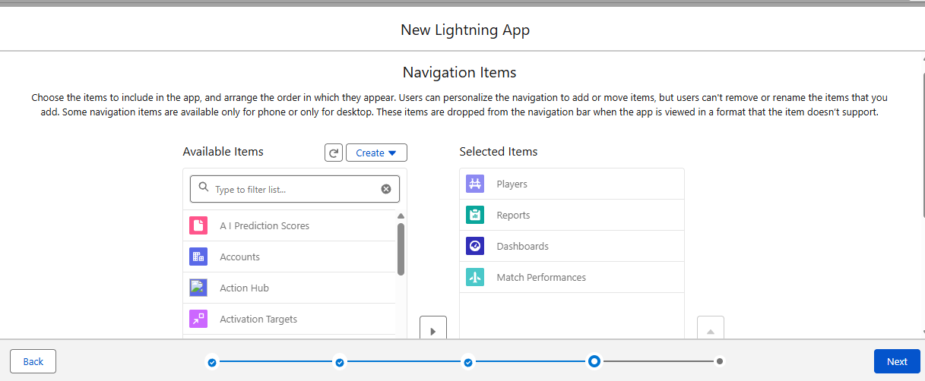

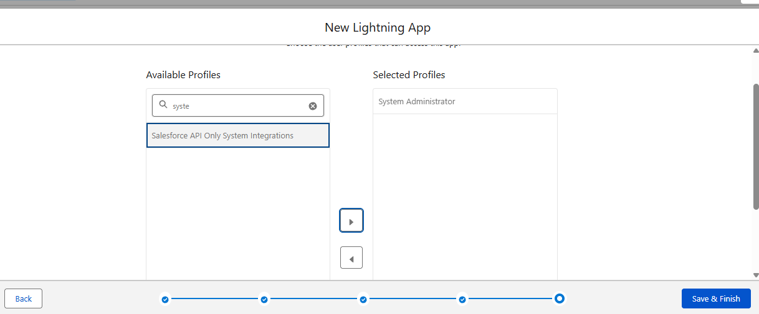

Milestone 5: Fields & Relationships

Activity 1: Create Custom Fields for Player Object
- In your Salesforce org, click the Gear icon on the top left and select Setup to open Setup.
- Click the Object Manager tab. If you don’t see it, enter Object Manager in the Quick Find box.
- From the Object Manager page, in the Quick Find box, search for the custom object you just created: Player.
- From the sidebar, click Fields & Relationships. Notice that there are already some fields there. Those are the standard fields.
- Click New to create a custom field. Before creating a new field, do a quick search to make sure a similar one doesn’t already exist.
- Next, choose a data type as Text. Choosing a data type helps you format the field input.

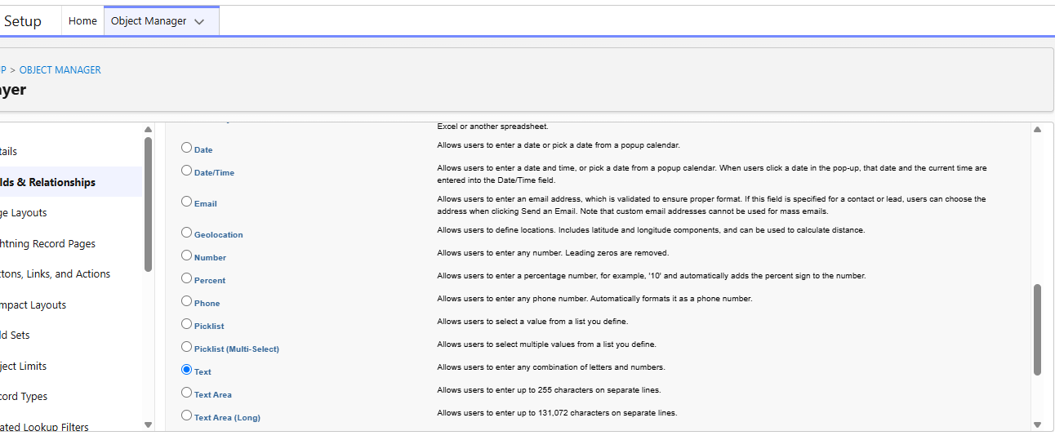
- Click Next.
- Data Type: Text
- Field Label: Player Name
- Field Name: Auto Populates
- Length: 50
Click on Next → Next → Save and New.
- Repeat the same steps for the remaining fields.

Player Number
- Data Type: Text
- Field Label: Player Number
- Field Name: Auto Populates
- Length: 3
Click on Next → Next → Save and New.

Profile Picture
- Data Type: Rich Text Area
- Field Label: Profile Picture
- Field Name: Auto Populates
Click on Next → Next → Save and New.

Date of Birth
- Data Type: Date
- Field Label: Date of Birth
- Field Name: Auto Populates
Click on Next → Next → Save and New.

Role
- Data Type: Picklist
- Field Label: Role
- Field Name: Auto Populates
- Values:
  - Batsman
  - Bowler
  - Batsman & Wicket Keeper
  - All Rounder

Batting Style
- Data Type: Picklist
- Field Label: Batting Style
- Field Name: Auto Populates
- Values:
  - Right-Handed
  - Left-Handed
Click on Next → Next → Save and New.

Bowling Style
- Data Type: Picklist
- Field Label: Bowling Style
- Field Name: Auto Populates
- Values:
  - Right-Arm Fast
  - Left-Arm Fast
  - Right-Arm Medium
  - Left-Arm Medium
  - Right-Arm Spin
  - Left-Arm Spin
Click on Next → Next → Save and New.

Nationality
- Data Type: Picklist
- Field Label: Nationality
- Field Name: Auto Populates
- Values:
  - Australia
  - Bangladesh
  - England
  - India
  - New Zealand
  - Pakistan
  - South Africa
  - Sri Lanka
  - West Indies
  - Afghanistan
  - Zimbabwe
  - Ireland
  - Scotland
  - Netherlands
  - United Arab Emirates
  - Nepal
  - United States of America
Click on Next → Next → Save and New.

Team
- Data Type: Picklist
- Field Label: Team
- Field Name: Auto Populates
- Values:
  - Chennai Super Kings (CSK)
  - Delhi Capitals (DC)
  - Kolkata Knight Riders (KKR)
  - Mumbai Indians (MI)
  - Punjab Kings (PBKS)
  - Rajasthan Royals (RR)
  - Royal Challengers Bangalore (RCB)
  - Sunrisers Hyderabad (SRH)
  - Gujarat Titans (GT)
  - Lucknow SuperGiants (LSG)

AVG Score
- Data Type: Formula
- Field Label: AVG Score
- Field Name: Auto Populates
- Formula Return: Number
Formula:
IF(
Matches_Played__c > 0,
Total_Runs__c / Matches_Played__c,
0
)
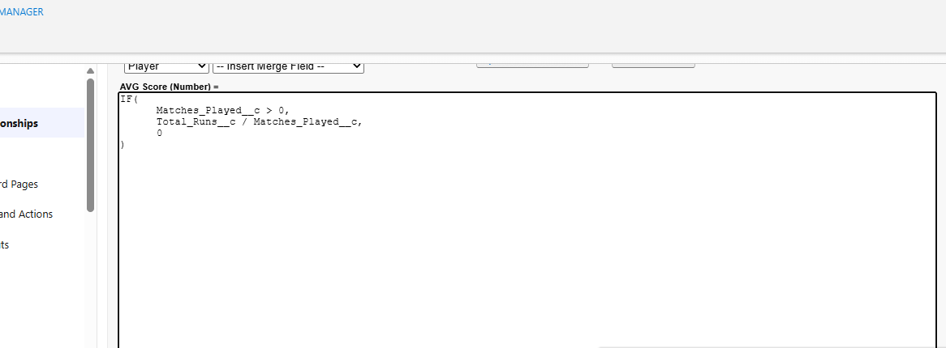
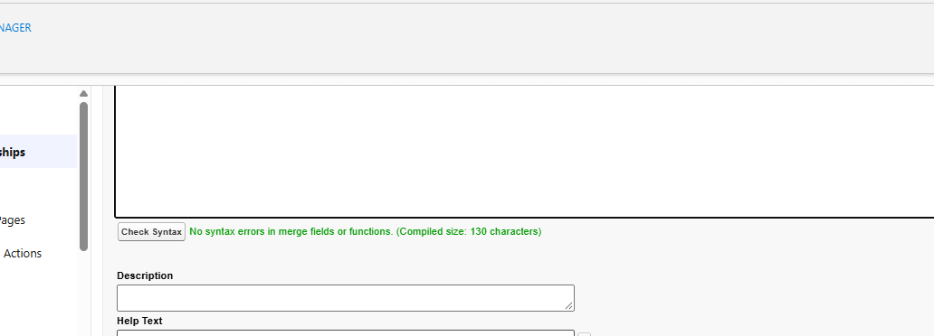
Click on Next → Next → Save & New.

Match Performance Lookup Relationship
- Data Type: Lookup Relationship
- Related To: Match Performance
- Field Label: Match Performance
- Field Name: Auto Populates
Click on Next → Next → Save.

Activity 2: Create Custom Fields for Match Performance Object

1. Match Performance Name
- Data Type: Text
- Field Label: Match Performance Name
- Field Name: Auto Populates
- Length: 80
Click on Next → Next → Save and New.

2. Player of the Match
- Data Type: Checkbox
- Field Label: Player of the Match
- Field Name: Auto Populates
Click on Next → Next → Save and New.

3. Match Result
- Data Type: Picklist
- Field Label: Match Result
- Field Name: Auto Populates
- Values:
  - WON
  - LOST
  - DRAW
Click on Next → Next → Save and New.

4. Runs Scored
- Data Type: Number
- Field Label: Runs Scored
- Field Name: Auto Populates
Click on Next → Next → Save and New.

5. Balls Faced
- Data Type: Number
- Field Label: Balls Faced
- Field Name: Auto Populates
Click on Next → Next → Save and New.

6. Fours
- Data Type: Number
- Field Label: Fours
- Field Name: Auto Populates
Click on Next → Next → Save and New.

7. Sixes
- Data Type: Number
- Field Label: Sixes
- Field Name: Auto Populates
Click on Next → Next → Save and New.

8. Overs Bowled
- Data Type: Number
- Field Label: Overs Bowled
- Field Name: Auto Populates
Click on Next → Next → Save and New.

9. Wickets Taken
- Data Type: Number
- Field Label: Wickets Taken
- Field Name: Auto Populates
Click on Next → Next → Save and New.

10. Runs Conceded
- Data Type: Number
- Field Label: Runs Conceded
- Field Name: Auto Populates
Click on Next → Next → Save and New.

11. Maiden Overs
- Data Type: Number
- Field Label: Maiden Overs
- Field Name: Auto Populates
Click on Next → Next → Save and New.

12. Stumpings
- Data Type: Number
- Field Label: Stumpings
- Field Name: Auto Populates
Click on Next → Next → Save and New.

13. Catches
- Data Type: Number
- Field Label: Catches
- Field Name: Auto Populates
Click on Next → Next → Save and New.

14. Player Master-Detail Relationship
- Data Type: Master-Detail Relationship
- Related To: Player
- Field Label: Player
- Field Name: Auto Populates
Click on Next → Next → Save.

Milestone 6: Roll-up Summary

Activity 1: Create Roll-up Summary for Player Object
Note: Roll-up Summary can only be created on the parent object in a Master-Detail Relationship.
- In your Salesforce org, click the Gear icon on the top left and select Setup to open Setup.
- Click the Object Manager tab. If you don’t see it, enter Object Manager in the Quick Find box.
- From the Object Manager page, in the Quick Find box, search for the custom object you just created: Player.
- From the sidebar, click Fields & Relationships. Notice that there are already some fields there. Those are the standard fields.
- Click New to create a custom field. Before creating a new field, do a quick search to make sure a similar one doesn’t already exist. Click Next.
- Choose a data type as Roll-up Summary. Click Next.

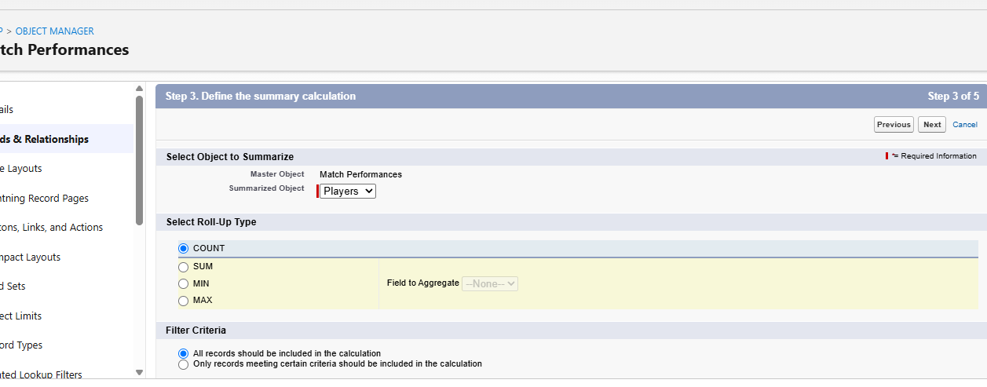

Matches Played
- Data Type: Roll-up Summary
- Field Label: Matches Played
- Field Name: Auto Populates
- Summarized Object: Match Performances
- Select Roll-up Type: COUNT
- Filter Criteria: All records should be included in the calculation.
Click on Next → Next → Save and New.

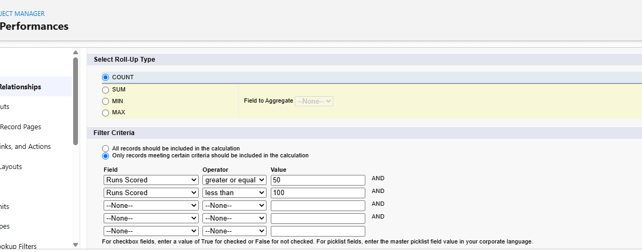
Number of 50’s
- Data Type: Roll-up Summary
- Field Label: Number of 50’s
- Field Name: Auto Populates
- Summarized Object: Match Performances
- Select Roll-up Type: COUNT
- Filter Criteria: Only records meeting certain criteria should be included in the calculation.
Click on Next → Next → Save and New.

Number of 100’s
Continue with the Roll-up Summary field creation for Number of 100’s using the same procedure.

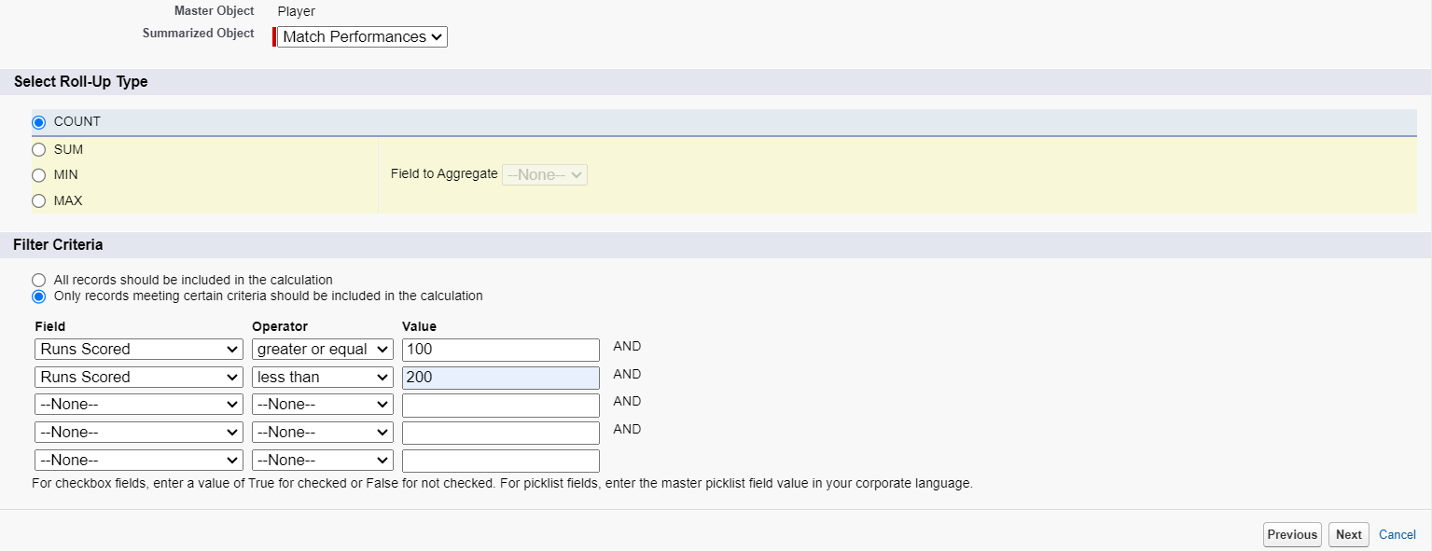

- Data Type : Roll-up Summary
Field Label: Total 4’s
Field Name : Auto Populates
Summarized Object : Match Performances
Select Roll-up Type : SUM
Field To Aggregate : Fours
Filter Criteria : All records should be included in the calculation.
Click on Next → Next → Save and new.

- Data Type : Roll-up Summary
Field Label: Total 6’s
Field Name : Auto Populates
Summarized Object : Match Performances
Select Roll-up Type : SUM
Field To Aggregate : Sixes
Filter Criteria : All records should be included in the calculation.
Click on Next → Next → Save and new.

- Data Type : Roll-up Summary
Field Label: Total Runs
Field Name : Auto Populates
Summarized Object : Match Performances
Select Roll-up Type : SUM
Field To Aggregate : Runs Scored
Filter Criteria : All records should be included in the calculation.
Click on Next → Next → Save and new.

- Data Type : Roll-up Summary
Field Label: Total Overs
Field Name : Auto Populates
Summarized Object : Match Performances
Select Roll-up Type : SUM
Field To Aggregate : Overs Bowled
Filter Criteria : All records should be included in the calculation.
Click on Next → Next → Save and new.

- Data Type : Roll-up Summary
Field Label: Total Wickets
Field Name : Auto Populates
Summarized Object : Match Performances
Select Roll-up Type : SUM
Field To Aggregate : Wickets Taken
Filter Criteria : All records should be included in the calculation.
Click on Next → Next → Save and new.

- Data Type : Roll-up Summary
Field Label: Total Stumpings
Field Name : Auto Populates
Summarized Object : Match Performances
Select Roll-up Type : SUM
Field To Aggregate : Stumpings
Filter Criteria : All records should be included in the calculation.
Click on Next → Next → Save and new.

- Data Type : Roll-up Summary
Field Label: Total Catches
Field Name : Auto Populates
Summarized Object : Match Performances
Select Roll-up Type : SUM
Field To Aggregate : Catches
Filter Criteria : All records should be included in the calculation.
Click on Next → Next → Save and new.

Milestone 7 : Flows

Activity 1 : Screen Flow

- Go to setup, Type Flow in quick find box → Click on the Flow and Select the New Flow.

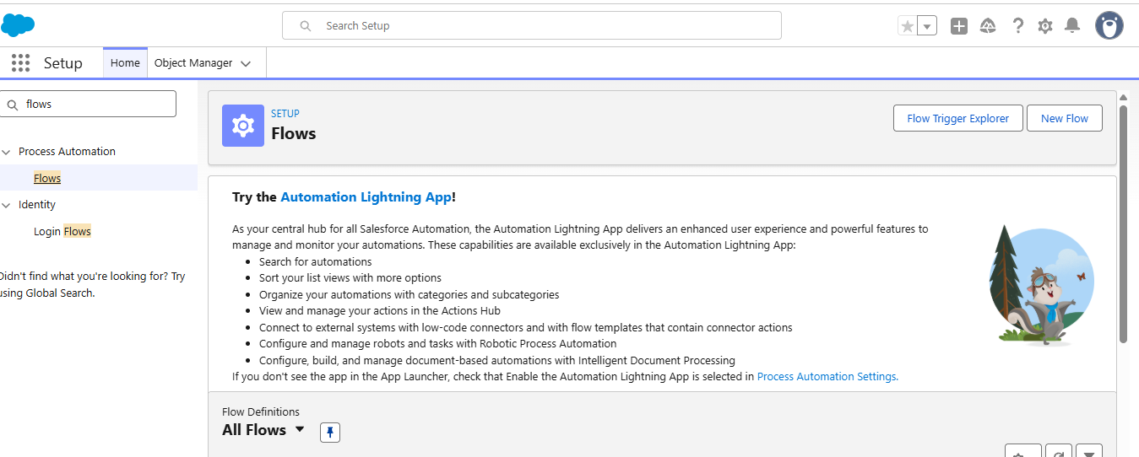
- Select Screen Flow and click Create.
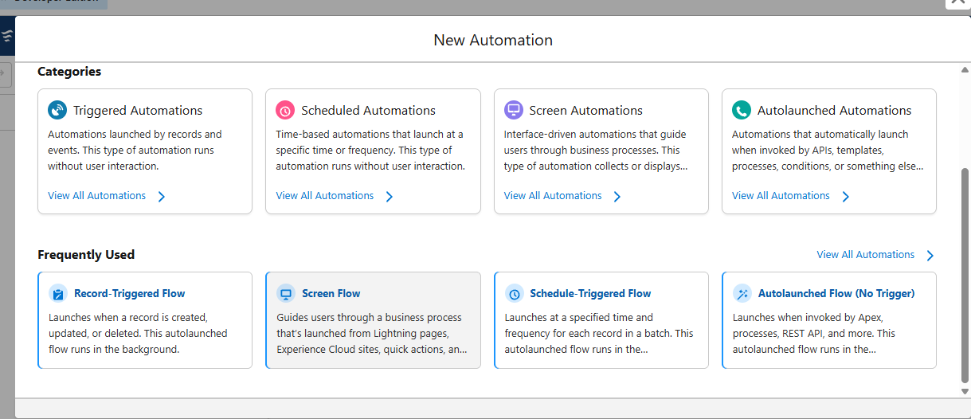
- Click (+) Icon on the flow builder and Select Screen Component.
Label : Players screen
API : Players_screen
Select the Picklist component and place it on the screen.
Label : Team
API : Team
From Component Pane on the left side select Component Type : Picklist
Data Type : Text
Choice : Click New Choice Resources
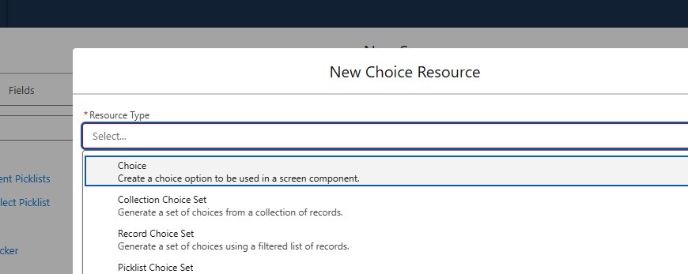
Resource Type : Picklist Choice Set
API Name : Team
Object : Player
Data Type : Picklist
Field : Team
Click Done.
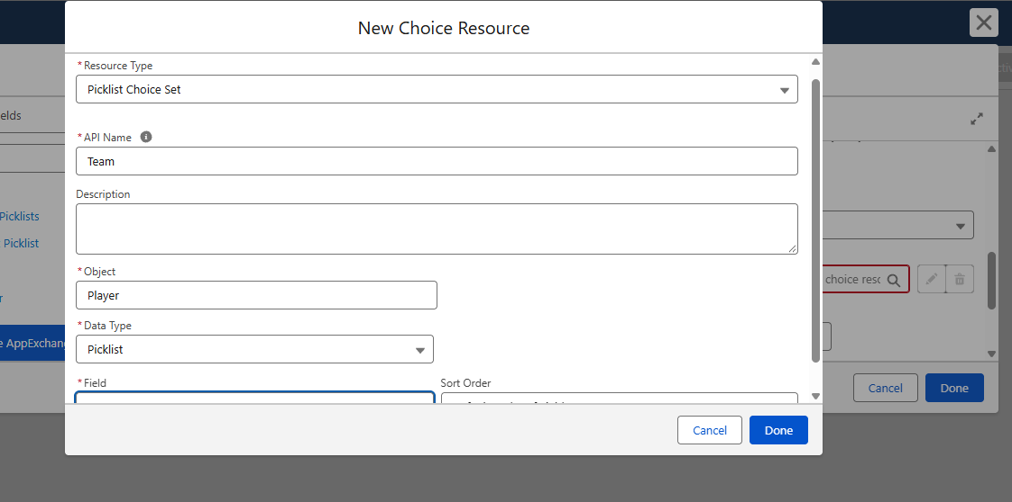
- Click (+) Icon on the flow builder and Select Get Records Component.
Label : Players
API Name : Players
Object : Player
Filter player records :
Field : Team
Operator : Equals
Value : Click New Resource
Resource Type : Variable
API Name : Dynamic
Data Type : Text
Default Value : Screen component : Team (Picklist)
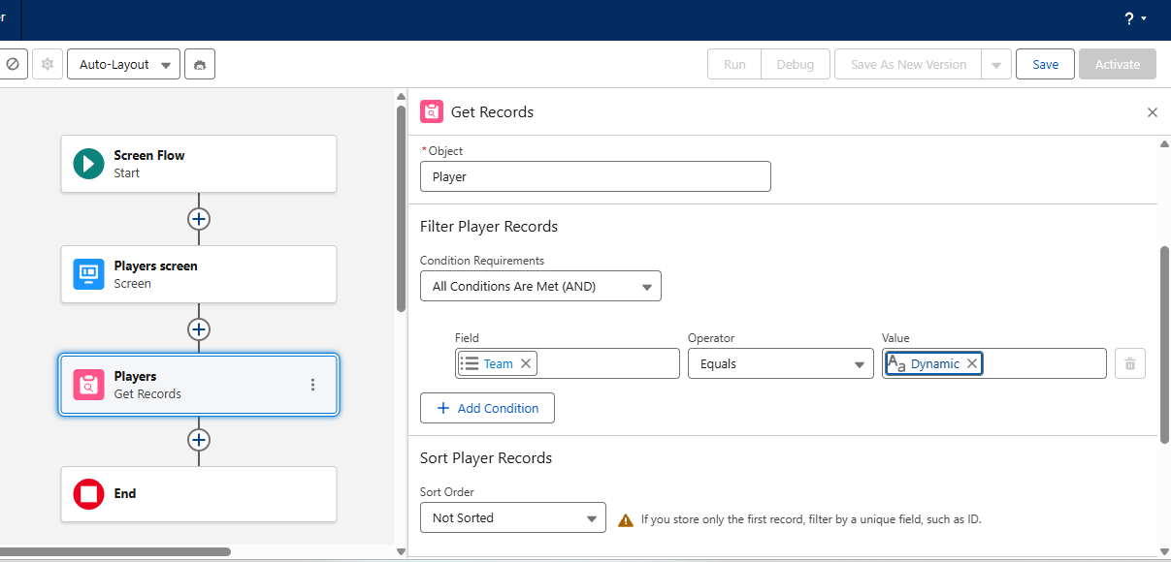
- Click (+) Icon on the flow builder and Select Screen Component.
Label : Player_info
API Name : Player_info
From Component Pane on the left side select Component Type : Data table
API Name : Player_info_table
Label : Data Table
Configure Data Source : Source Collection : Players from players (Player__c)

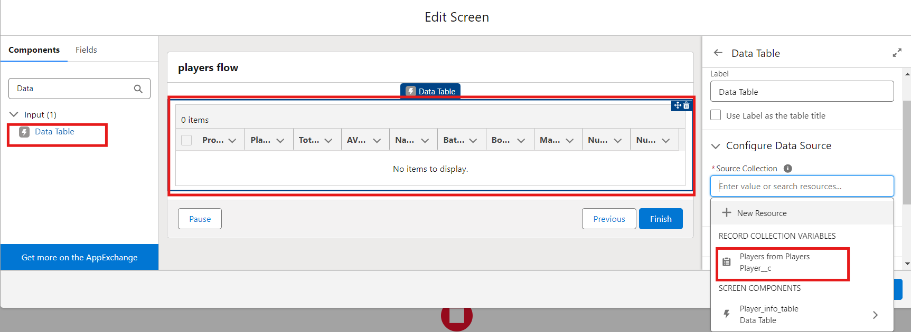

In Configure Columns : Add all the required Columns
Profile Picture | Player Name | Total Runs | AVG Score | Batting Style | Bowling Style | Matches Played | Number of 50’s | Number of 100’s
Click Done.
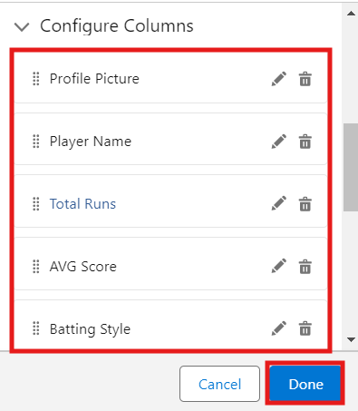

Click Save.
Flow Label : Player Flow
Flow API Name : Player_Flow

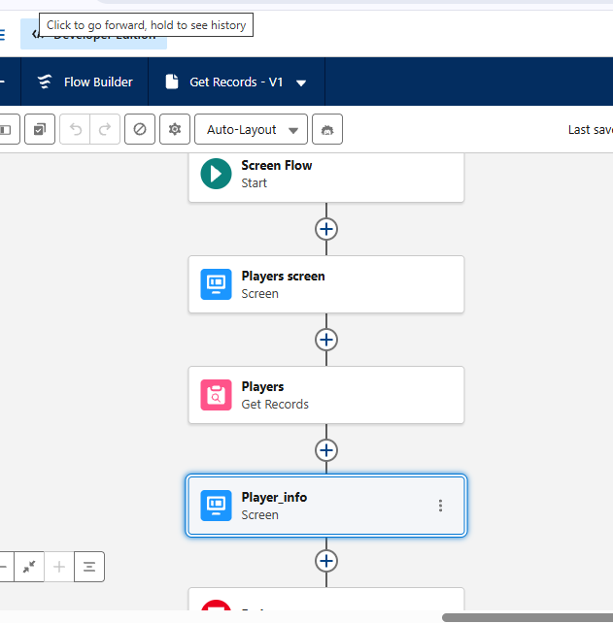

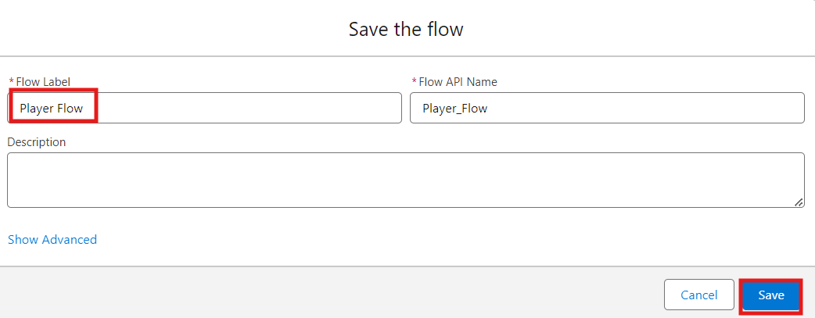

Activity 2 : Flow on Home Page

- On your CRICKSTATS Application on the top right of the Navigation Bar click on Personalize your nav bar icon (Pencil Icon) and Add Home Page and click Save.

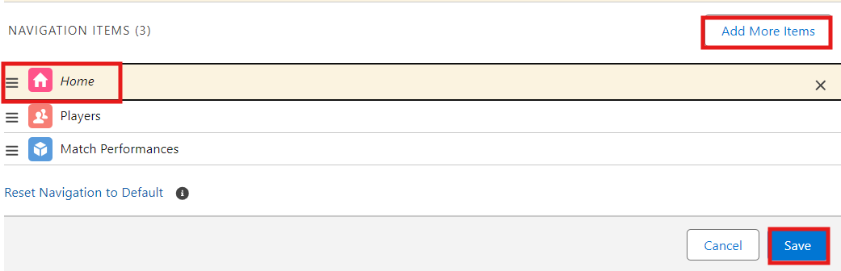

- Remove all other components and Add FLOW component from the standard components on the left side.
- Flow : Players Flow

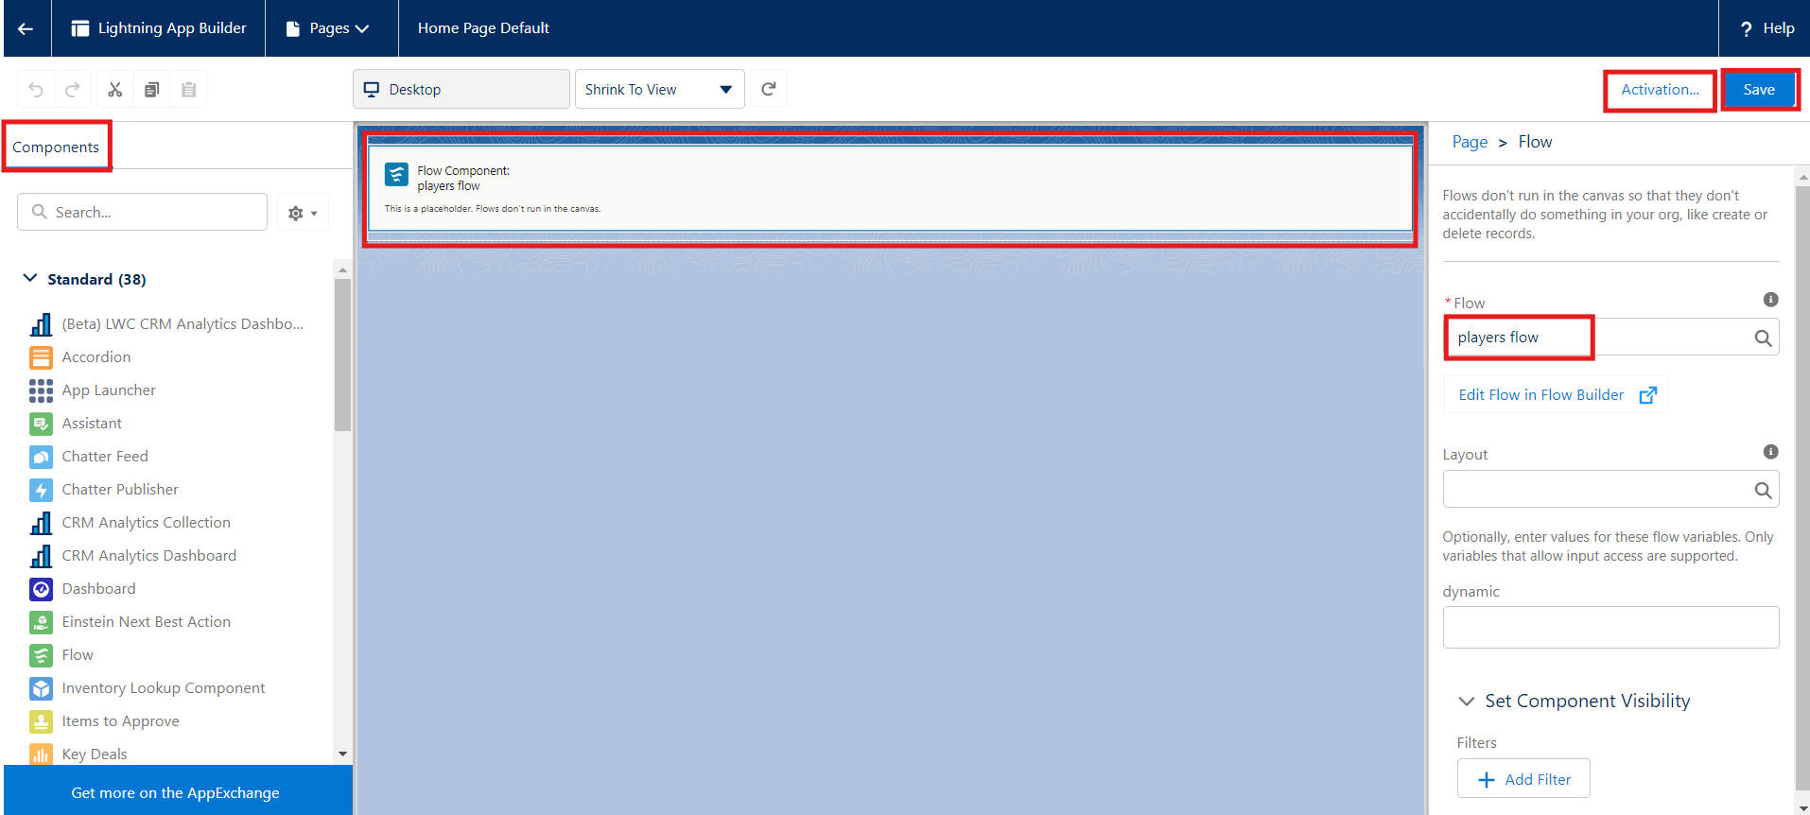

- Click Save and Activation.
- Click on App Default and select Assign to Apps.

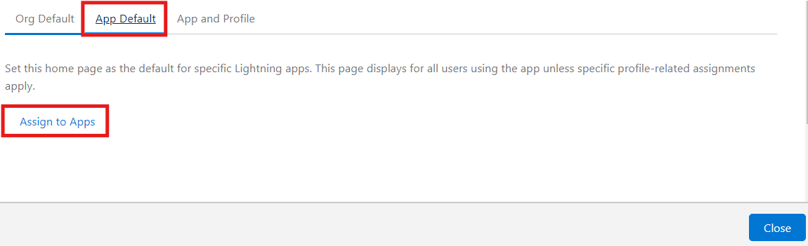
- Select CRICKSTAS App and Click Next and then click Save.

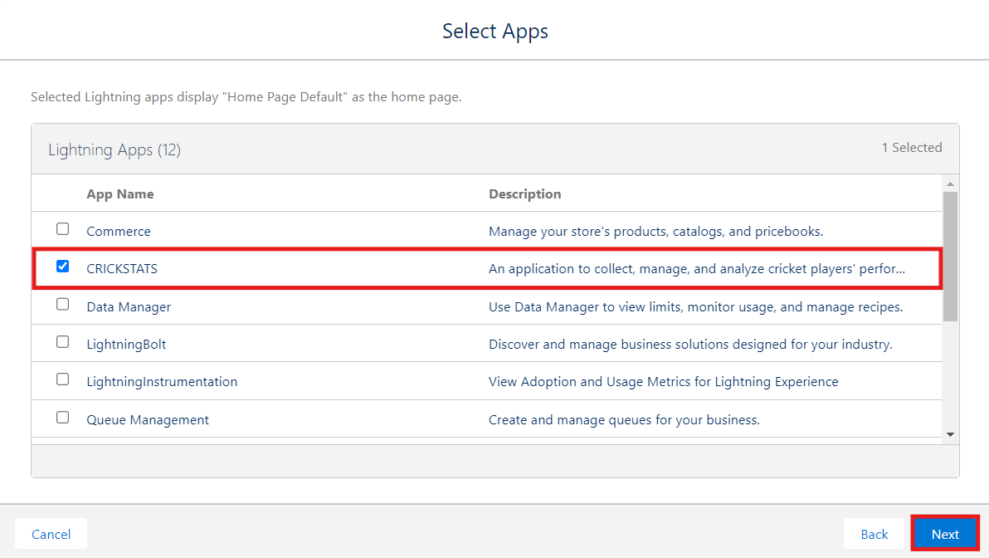

7. FUNCTIONAL & PERFORMANCE TESTING
During the testing phase, screenshots were captured from the Salesforce Lightning user interface to verify the correct functioning of all implemented features in the CRICKSTATS system. These include record creation for Player and Match Performance objects; validation rule checks for mandatory fields, score limits, and input constraints; verification of record type behavior for Domestic and International match categories; and flow execution for automatic updating of player statistics and data consistency.
The functionality of roll-up summary fields was also tested to ensure accurate calculation of total runs, wickets, averages, and performance metrics.
In addition, system performance was evaluated by monitoring response time during data entry, report generation, and dashboard loading. The application was tested under multiple user interactions to ensure stable performance without delays.
Screenshots of generated reports and interactive dashboards were documented to confirm accurate data visualization, real-time updates, and reliable performance tracking. These testing activities ensured that the CRICKSTATS platform met both functional and performance requirements and was ready for deployment.
NOTE : Enter some records in the Player Object and Match Performance Object to get the results.

- Select one Team from the Picklist and Click Next.
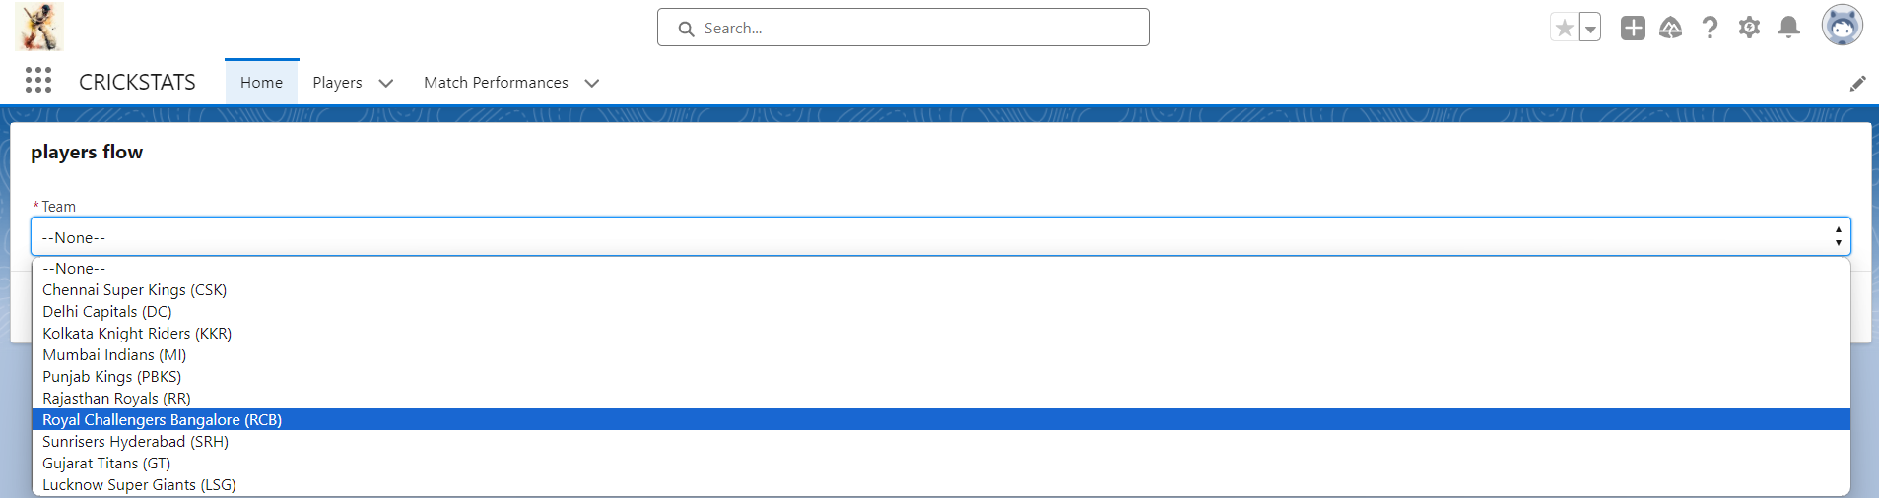

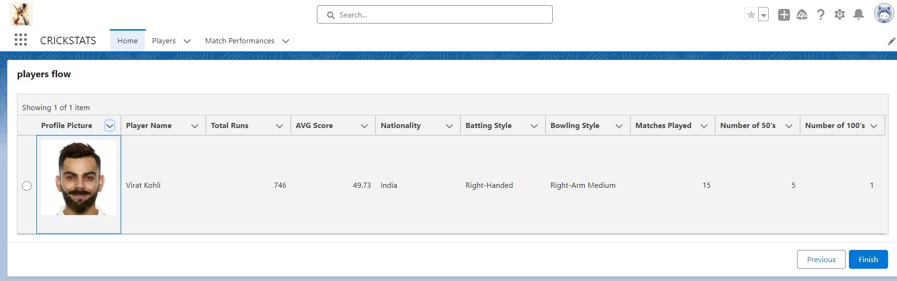
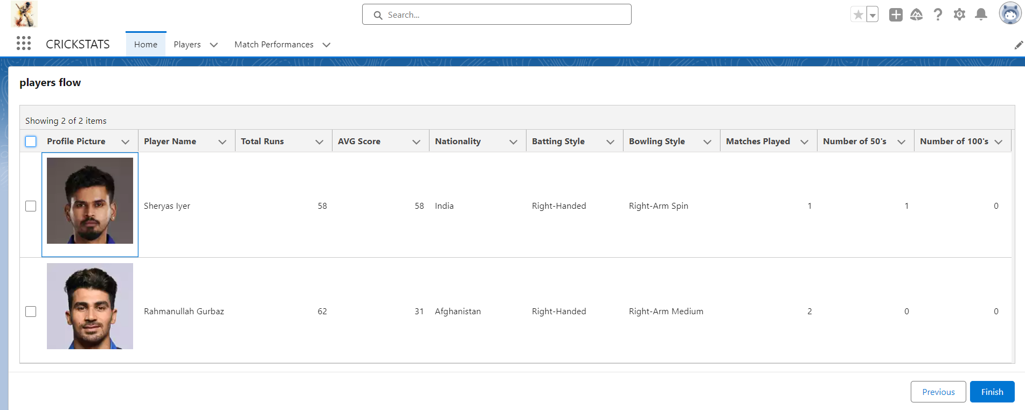

8. ADVANTAGES & DISADVANTAGES

Advantages
- Centralized system
- Real-time analytics
- Secure platform
- Scalable design
- Reduced manual work

Disadvantages
- Requires Salesforce license
- Internet dependency
- Limited offline access

9. Conclusion
CRICKSTATS successfully implements a cloud-based cricket performance tracking system using Salesforce. The system automates data management, improves reporting accuracy, and supports informed decision-making.
The project demonstrates practical application of SDLC, Agile methodology, and CRM-based development.
10. FUTURE SCOPE
- Mobile application integration
- AI-based performance prediction
- Video analysis integration
- Player ranking system
- Public statistics portal
- Multi-league support

11. APPENDIX
- Salesforce Objects & Fields
- Manual match statistics
- Flow Configurations

THANK YOU

